Lab 7

void draw_1_side(){

turn_right_by_degrees(360/50.0);

draw_distance(5);

}

void draw_circle(int n){

if (n>0){

draw_1_side();

note_position();

draw_circle(n-1);

}

}

void background(){

cout<< "Enter the time of day: 0-23? ";

const int t = read_int();

make_window(800,500);

if(t <= 4 && t >= 0){

fill_rectangle(0,0,800,500,color::black);

set_pen_color(color::grey);

move_to(600,100);

}

if (t <= 8 && t >= 5){

fill_rectangle(0,0,800,500,color::orange);

set_pen_color(color::yellow);

move_to(600,200);

}

if (t <= 14 && t >= 9){

fill_rectangle(0,0,800,500,color::light_blue);

set_pen_color(color::yellow);

move_to(650,100);

}

if (t <= 19 && t >= 15){

fill_rectangle(0,0,800,500,color::dark_blue);

set_pen_color(color::orange);

move_to(700,100);

}

if (t <= 23 && t >= 20){

fill_rectangle(0,0,800,500,color::black);

set_pen_color(color::grey);

move_to(600,100);

}

start_shape();

draw_circle(360);

fill_shape();

}

void grey_mountains(double N){

if (N > 0){

set_heading_degrees(random_in_range(45,60));

draw_distance(random_in_range(100,150));

note_position();

set_heading_degrees(random_in_range(120,135));

draw_distance(random_in_range(100,150));

note_position();

grey_mountains(N-1);

}

}

void red_mountains(int P){

if (P > 0){

set_heading_degrees(random_in_range(110,120));

draw_distance(random_in_range(100,150));

note_position();

set_heading_degrees(random_in_range(50,70));

draw_distance(random_in_range(100,150));

note_position();

red_mountains(P-1);

}

}

void green_mountains(int G){

if (G > 0){

set_heading_degrees(random_in_range(110,120));

draw_distance(random_in_range(25,75));

note_position();

set_heading_degrees(random_in_range(55,75));

draw_distance(random_in_range(25,75));

note_position();

green_mountains(G-1);

}

}

void mountains(int N, int P, int G){

move_to(0,250); // grey

set_pen_color(color::grey);

start_shape();

grey_mountains(N);

move_to(800,500);

note_position();

move_to(0,500);

note_position();

move_to(0,250); //

note_position();

fill_shape();

move_to(0,275); // red

set_pen_color(color::red);

start_shape();

red_mountains(P);

move_to(800,500);

note_position();

move_to(0,500);

note_position();

move_to(0,275); //

note_position();

fill_shape();

move_to(0,320); // green

set_pen_color(color::dark_green);

start_shape();

green_mountains(G);

move_to(800,500);

note_position();

move_to(0,500);

note_position();

move_to(0,320); //

note_position();

fill_shape();

}

// single window

void single_window(int h, int w, int x, int y){

fill_rectangle(x, y, w, h, color::black);

}

// row of windows

void row_of_windows(int h, int w, int x, int y, int N){

if (N > 0){

single_window(h,w,x,y);

move_to(x,y);

row_of_windows(h, w, x + (w + 10) ,y , N - 1);

}

}

// block of windows

void block_of_windows(int h, int w, int x, int y, int N, int C){

if (C > 0){

row_of_windows(h,w,x,y,N);

move_to(x,y);

block_of_windows(h,w,x, y + (h + 10), N, C - 1);

}

}

// office building

void draw_building(int x, int y){

start_shape();

move_to(x,y);

note_position();

double r = random_in_range(0,100) * 0.01;

double g = random_in_range(0,100) * 0.01;

double b = random_in_range(0,100) * 0.01;

set_pen_color(r, g, b);

set_heading_degrees(0);

const int h = random_in_range(150,400);

const int w = random_in_range(100,200);

draw_distance(h);

note_position();

turn_right_by_degrees(90);

draw_distance(w);

note_position();

turn_right_by_degrees(90);

draw_distance(h);

note_position();

turn_right_by_degrees(90);

draw_distance(w);

note_position();

fill_shape();

int N = random_in_range(4,7);

int C = random_in_range(5,9);

int w_window = (w/N) - 10;

int h_window = (h/C) - 15;

int x_window = x + 10;

int y_window = (y - h) + 10;

block_of_windows(h_window, w_window, x_window, y_window, N, C);

}

// draw city

void draw_city(int x, int y){

int width_left = 800 - x;

int width_between_buildings = random_in_range(180,250);

if (width_left > width_between_buildings){

draw_building(x, y);

draw_city(x + width_between_buildings, y);

}

}

// houses

const double pi = acos(-1.0);

const double deg2rad = pi/180.0;

void single_house_window(int h, int w, int x, int y){

fill_rectangle(x, y, w, h, color::light_blue);

}

void row_house_windows(int h, int w, int x, int y, int N){

if (N > 0){

single_house_window(h,w,x,y);

move_to(x,y);

row_house_windows(h, w, x + (w + 10) ,y , N - 1);

}

}

void block_house_windows(int h, int w, int x, int y, int N, int C){

if (C > 0){

row_house_windows(h,w,x,y,N);

move_to(x,y);

block_house_windows(h,w,x, y + (h + 10), N, C - 1);

}

}

void draw_house(int x, int y){

int w = random_in_range(75,150);

int h = random_in_range(75,150);

fill_rectangle(x, y - h, w, h, color::yellow);

start_shape();

set_pen_color(color::brown);

int x2 = x - 5;

int y2 = y - h;

move_to(x2, y2);

note_position();

set_heading_degrees(90);

draw_distance(w + 10);

note_position();

double theta = random_in_range(45,60);

set_heading_degrees(270 + theta);

const int side_length = (w/2 + 5)/cos(theta * deg2rad);

draw_distance(side_length);

note_position();

set_heading_degrees(270 - theta);

draw_distance(side_length);

note_position();

fill_shape();

int N = random_in_range(2,4);

int C = random_in_range(2,3);

int w_window = (w/N) - 15;

int h_window = (h/C) - 15;

int x_window = x + 10;

int y_window = (y - h) + 10;

block_house_windows(h_window, w_window, x_window, y_window, N, C);

}

void draw_suburbs(int x, int y){

int width_left = 800 - x;

int width_between_buildings = random_in_range(150,200);

if (width_left > width_between_buildings){

draw_house(x, y);

draw_suburbs(x + width_between_buildings, y);

}

}

// trees

void draw_leaves(int x, int y, int count){

if (count > 0){

set_pen_color(color::green);

set_pen_width(random_in_range(1,5));

move_to(x + random_in_range(-15,15), y + random_in_range(-15,15));

draw_point();

draw_leaves(x, y, count - 1);

}

}

void draw_tree(int x, int y){

move_to(x,y);

set_pen_color(color::brown);

set_pen_width(5);

set_heading_degrees(0);

int h = random_in_range(45,60);

draw_distance(h);

draw_leaves(x, y - h, 150);

}

void draw_multiple_trees(int x, int y){

int width_left = 800 - x;

int width_between_trees = random_in_range(25,200);

if (width_left > width_between_trees){

draw_tree(x, y);

draw_multiple_trees(x + width_between_trees, y);

}

}

void main(){

background();

mountains(8, 10, 20);

draw_city(50, 500);

draw_suburbs(150,500);

draw_multiple_trees(50,500);

}

7 o’clock

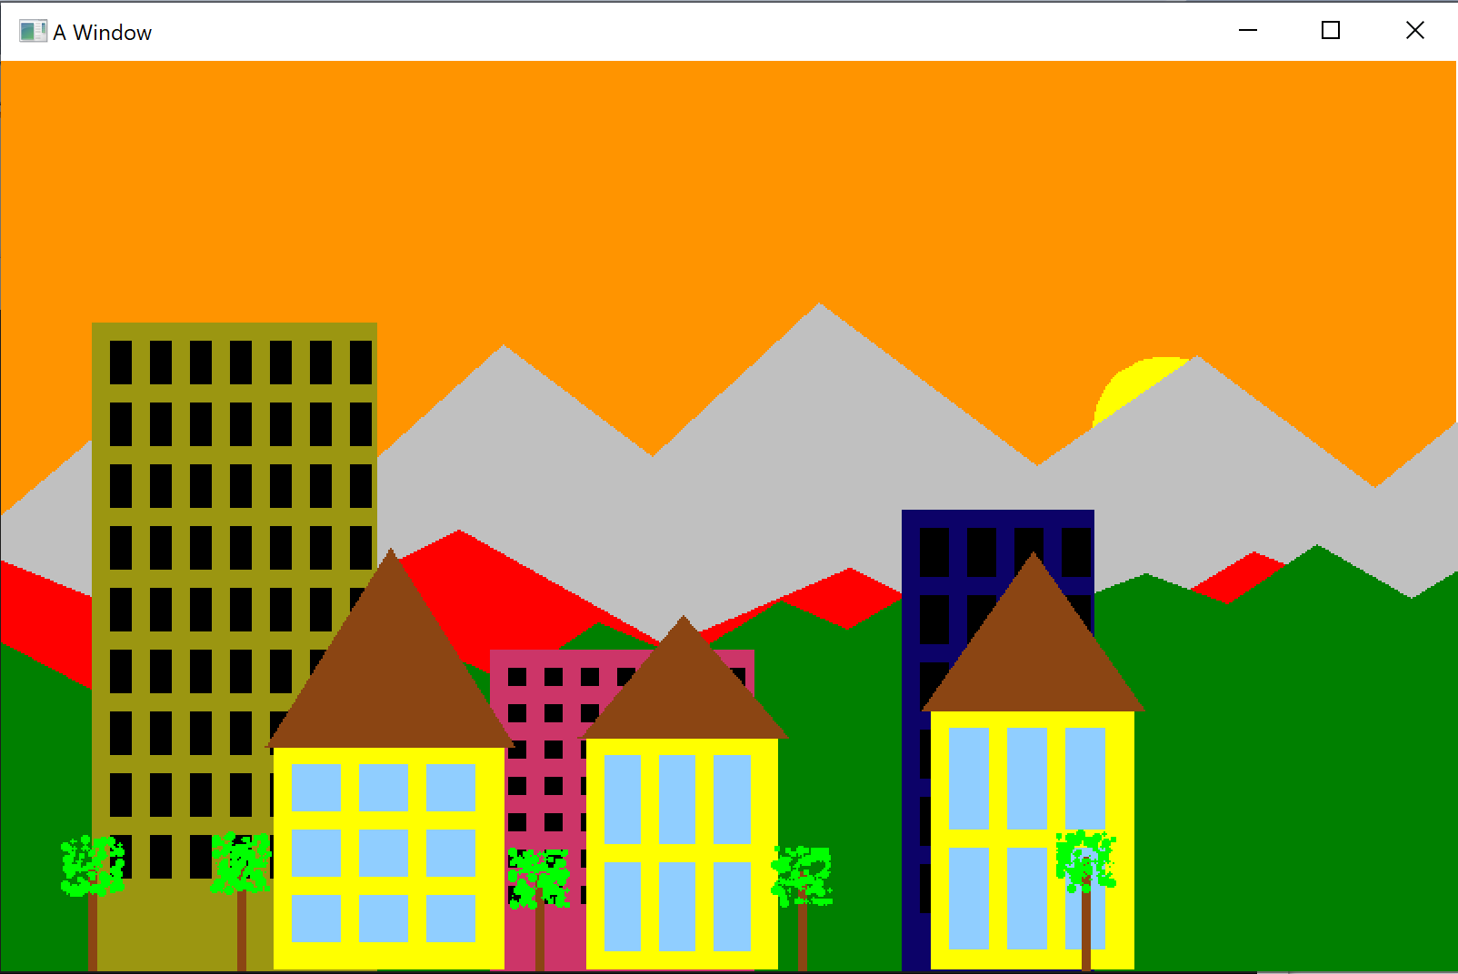

22 o’clock

